***---------------------------------------Assignment Part-2-----------------------------------------***

1. Create a file like **nano file1.txt**

* Edit some data and then save the file

Ans-

1. There are two processes to create a file, the cat command, and the touch command. In the Touch command, we can create a blank file.
2. In the cat command, we can add the content instantly.
3. We can create the file with the cat command and add the desired content to the file.

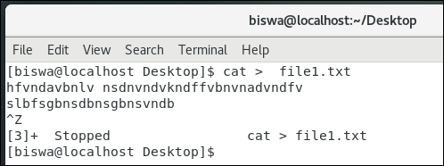

2. Now we will copy date from file1 to new file2

* **cp file1.txt file2.txt**
* Then see the output of file2.txt, **cat file2.txt**
* Give screenshot

Ans-

1. I created the 1st file named file1.txt and add a few data and then save the file.
2. Using the touch command file2.txt has been created.
3. Using the cp command content of file1.txt has been copied to file2.txt
4. Using the cat command we can see the content of any file.

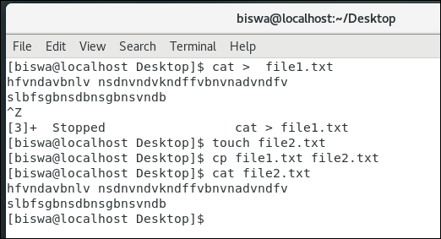

3. Now we will move the file2.txt to new folder **/home**

* **mv file2.txt /home**
* Then go to **home** directory and check **ls,** file exits or not?
* Given screenshot

Ans-

1. Initially I tried to move the file2.txt to the home directory and got a permission denied error.
2. Then I tried the mv command followed by the sudo command and file2.txt is successfully moved to the home directory.
3. Using the ls command, we can see that file2.txt is now available under the home directory.

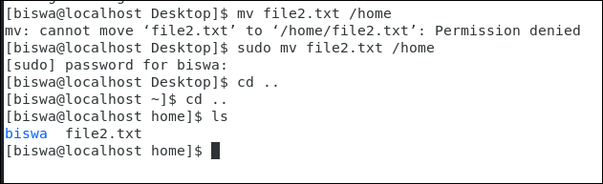

4. Then we create a new **file3.txt and file4.txt** in **home directory** and add

content in it.

* Now do **echo “Hello I am newline” > file3.txt** and provide the

output of file3.txt

* Now do **echo “Hello I am newline” >> file4.txt** and provide the

output of file4.txt

* Tell the different between both step you follow and the reason

behind it

Ans-

file3.txt and file4.txt have been created with some content by using cat command.

Added **“Hello I am newline” in** file3.txtusing the echo command with operator “>”. (Output attached below).

Added **“Hello I am newline” in** file4.txtusing the echo command with operator “>>”. (Output attached below).

**Conclusion: -** If we use Operator “>” then the newly inserted content will replace the old available content. On the other hand, if we use the operator “>>” then the newly added content gets appended to the existing content.

**file3.txt and file4.txt were created with some content.**

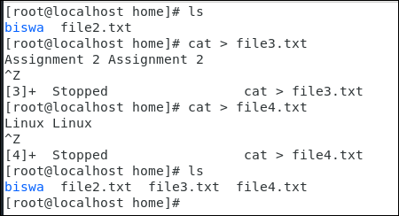

**Hello I am New Line added to file3.txt using echo command with “>”.**

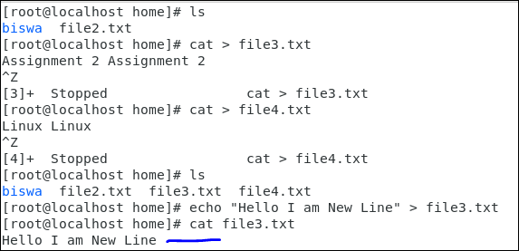

**Hello I am New Line added to file4.txt using echo command with “>>”.**

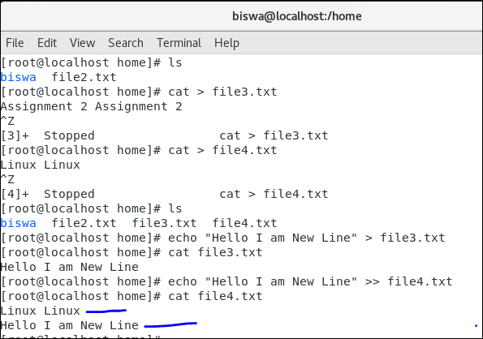

5. For remove a file or directory you can use the below two commands

* To delete a file – **rm <any_filename>**
* To delete a directory - **rmdir <any_directoryname>**

Ans-

